Harpoon game

By Luke Allenhj

Contents

Analysis 3

• Problem Identification – 3

• Stakeholders 4

• Computational Approach 4

• Research of the problems 4

• Interviews 5

o Continuous game 5

o Levels 5

o Level builder 5

• Hardware specifications 7

• Software specification 7

• Specify the proposed solution 7

• Limitations of the solution 8

Design 9

User interface 11

Algorithms 11

Design of AI algorithms 11

Implementation 12

Testing 13

Evaluation 14

# Analysis

## Problem Identification –

There are multiple online arcade games where people are able to play for short periods of time, whether it is in their lunch or coffee break or they just want to relax for a short amount of time. Although one major problem is that people get bored of these arcade games quickly due to there repetitiveness and lack of anything different. Another major problem is that a lot of people are split into preferring either reflex-based, intuitive, or creative games.

My idea is to create a game with all 3 different genres of arcade game, whereby the games is split into 3 different sections: Continuous, levels and self-built.

Continuous is a solo player unlimited score game where the player will press space to turn a gun on the screen, once player releases the space button, the gun will shoot a harpoon. If the space button was released at the correct time the harpoon will hit the next wooden block and the gun will replace the wooden block and you will be able to spin the gun again. This will be the reflex-based part of the game due to the fact that the speed at which the screen comes down and the speed at which the gun will turn will speed up. Every time you hit the correct wooden block a point will be added to your score – the aim of the game is to get the highest score therefore friends can compare results and compete in who can get the highest score. The wooden blocks will spawn above the gun and with random x coordinates.

In levels, I will have 6 levels to do. Here I will have already pre-made 6 levels, 3 of the levels will be speed trial and 3 will be puzzle (puzzle type is where there are many possible blocks that you can hit and many different routes but only one of the routes will get to the finishing block, speed trial is when there is 1 route which all get to the golden block but the main aim is to get to the golden block as fast as possible). This part of the game includes a mix of reflex-based and intuitive To be able to play level 2 of the speed trials, you will have to get a silver medal at the least in level 1, and to be able to play puzzle 2, you will have to have completed level 1 of the puzzle levels.

In Self-built, which you can unlock after reaching a score of 20 in continuous. To start off the creation of a level, the creator will need to state the name that they are giving the level, how hard they would rate the level out of five, and whether it is a puzzle level or a speed trial level. After this they will be able to start making their course, they’ll do this by selecting the colour, red or blue and then they will create areas made up of rectangles, after they create the rectangle they will then be able to turn they rectangle they created. After this they will be putting down their wooden blocks, golden block(s) [if more than one way to win] and checkpoint blocks if it is a really long speed trial. This final part of the game is a mix of intuitive and creative arcade games. This also allows more social activity as you will be able to share levels.

## Stakeholders

My stakeholders will be those in the general public with free time to spare. My main targets in the general public will be those less than 70; this is due to the people above 70 have significantly slower reflexes and therefore it will be hard for them to get scores exceeding 15.

The main targets will be kids in the age between 6 and 22 due to the amount of free time the possess and the higher percentage of gamers in the age group. The main target age bracket dropped to age of 6 because this game allows young kids to be creative in making levels and should help their non-verbal areas as they will be solving puzzle type levels as well. Specifically, my 6-year-old cousin Ki would be a stakeholder as it would help his creative side and also help his reflexes.

## Computational Approach

I believe this is a computational problem because the main problem is to create a game that has all 3 types of arcade games. By definition an arcade game is a type of computer game, this is because there aspects to these solutions that require a computer; for example the enemies need to control themselves and the screen needs to move itself downwards at a certain pace which might not be possible for a human due to time consuming equations. Also, another large problem is that this game is quick so that the clients will be able to play a game in their coffee breaks. If this was a board game, then less people would play because it is time consuming to set up.

## Research of the problems

Whilst researching for the solution to my problem and for the design of my game, I came across a few arcade games which I thought had some very good ideas which I could possibly implement into my game.

### Image result for mr gunImage result for mr gunMr Gun

Mr Gun is a game I found on my phone, where you are the player on the lower platform, and you have to shoot the bad guy above you; your gun starts at a horizontal level, then rotates anti-clockwise until either you shoot by tapping down on the phone, or by getting to the vertical line and then moving clockwise until either a shoot or it gets to horizontal line and repeats, when you get a headshot. Once the gunner has reached the 100th level, you in effect restart the level but keep your score, so it ends up being continuous. If you miss your shot, then the enemy shoots you and you die. After you die a death screen appears which a replay button, a leader board button and an Instagram button; it also shows your score and the best score. This game also has a coin system where you can buy guns in the store, or different skins for the gunner

The aspect about this game that I would like to incorporate into my game is the feature of once the gun has reached a specific direction, it will suddenly start turning the other way instead. I also wish to incorporate the idea that if you do not hit the enemy first time then you die. I also wish to use the death screen like in this game but instead of an Instagram button, a home button. I’m not going to have a coin system because in full honesty I do not know what the player would be buying with these games.

### Related imageImage result for angry birds levelsAngry Birds

Here in angry birds, there is a level screen, where you choose which level you want to do by clicking on the number, each level shows you what star rating you have out of 3. There is also a back button if you want to go back to the home screen. Within the actual levels the aim of the game is to knock over some premade towers by shooting birds at them; one factor you have to account for in this game is gravity.

I will be using the idea of putting a little symbol below my levels to show weather it is complete or has 3 stars. I will also be using the idea of just having a simple background like this. Another aspect that I may be taking from this game is the use of gravity in my levels – this will make it more interesting and put a completely new dynamic on it.

### Happy wheels game maker

### Super smash bros brawl

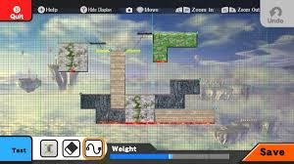

In super smash bros

### Minecraft

## Interviews/ Questionnaire

* + What do they want (enemies? gravity? Scoreboard? Time?)

### Interview

1. Do you play arcade games a lot?
   1. If not, why not?
2. On what console do you normally play video games and why?
3. Do you like it there are different parts of the game?
4. How long do you like the duration of a level in an arcade game?
5. What have you found to be the point scoring system?
6. Have you found brighter coloured games to be more annoying or better?
7. What normally makes you stop playing an arcade game?
8. If you made your own arcade game, what would you do to it to make it different?

Question 1 is really to see how useful the interviewee will be because if they do not play a lot of these games then they might not know as much on these games and they will not be the ones playing these games so their opinion is less on the priority list. Question 2 is to see what types of controls they prefer to use and why they think it is better. Question 3 is to see if my theory of people liking having more than one type of game to play. Question 4 is to see if they would prefer multiple games in their small breaks or 1 slightly longer game. Question 5 is due to the fact that some people hate types of scoring system like timed or distance. Question 6 is due to the fact that some people get distracted by having colour in the game whereas other prefer it. Questions 7 and 8 are to see what else I can add/ not add to the game to make game better.

### Questionnaire

* Continuous game

1. Would you like to see the score as you go, or would you like to only see it after you have died?
2. Do you think there should be trick wooden blocks later where they look slightly different and therefore if you attach onto them you die?
3. Do you think I should add extra wooden blocks so that you can get points quicker?

* Levels

1. Do you think that the user should have to get to a certain score on continuous to unlock levels?
   1. If so, what score do you think it should be?
2. For speed trial do you think that the time should be shown on the screen whilst the game is playing?
3. For puzzle do you believe that the screen should move vertically, horizontally or in direction of movement?

* Level builder

1. Do you think there should be a change in game control settings?
   1. If not, do you believe moving the screen should be done by (left mouse button held down + movement of cursor) or (button pressed [e.g. p] + movement of cursor) or (up, down, left and right keys)?
2. Should the blocks be created by using specific keys for specific blocks or by selecting a block from a list of blocks?
3. Should the blocks be selected using the left click of a mouse or by the blocks being numbered and then pressing on their number?
4. Should the rotation of a block be like the rotation of an image in word, using a bar or an entry of no. of degrees on the image?
5. Would you like to be able to scroll in and out of level when editing it?
6. Should player be allowed to scroll in and out of level when playing it?
7. Should the creator of a level have to complete the level for it to be classified as ‘playable’
8. Should editor be able to increase size of wood.

Questions 1 and 5 are there to see the proportion of people dislike having constantly changing numbers in the corners of the screen because it distracts them, question 2 is asking to see if the clients would like the game to get harder, after certain scores or whether they would prefer the game to just get faster. Question 3 is asking if the clients would prefer the game to be sped up at the start or not. Question 4 is to see if the clients would like an objective in the continuous area instead of just having to get highest score. Question 6 is there because most puzzles might not be linear, therefore the screen might have to move in different ways.

Question 7 is there because some people may like to change the game controls whereas others might want fixed original keys. Question 8 is to see who would find who prefers creating blocks quicker or easier.

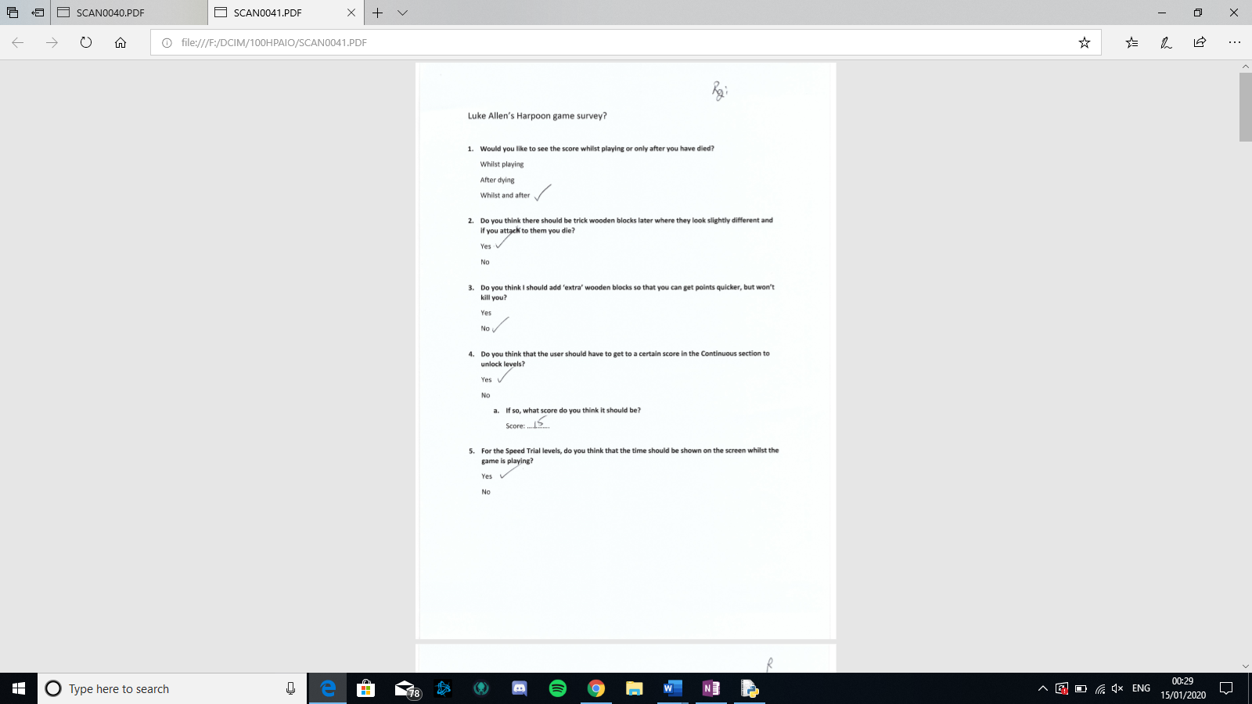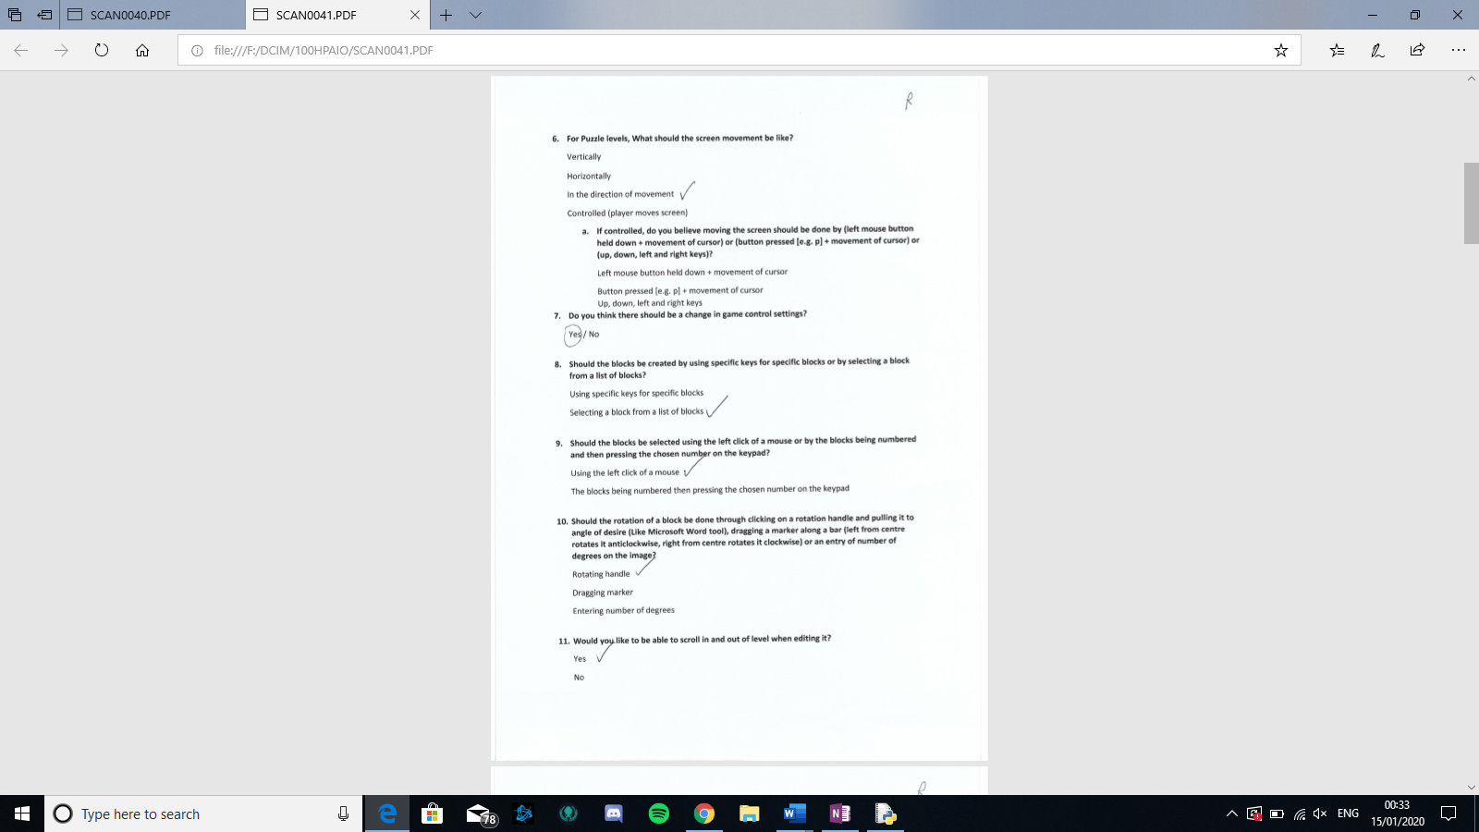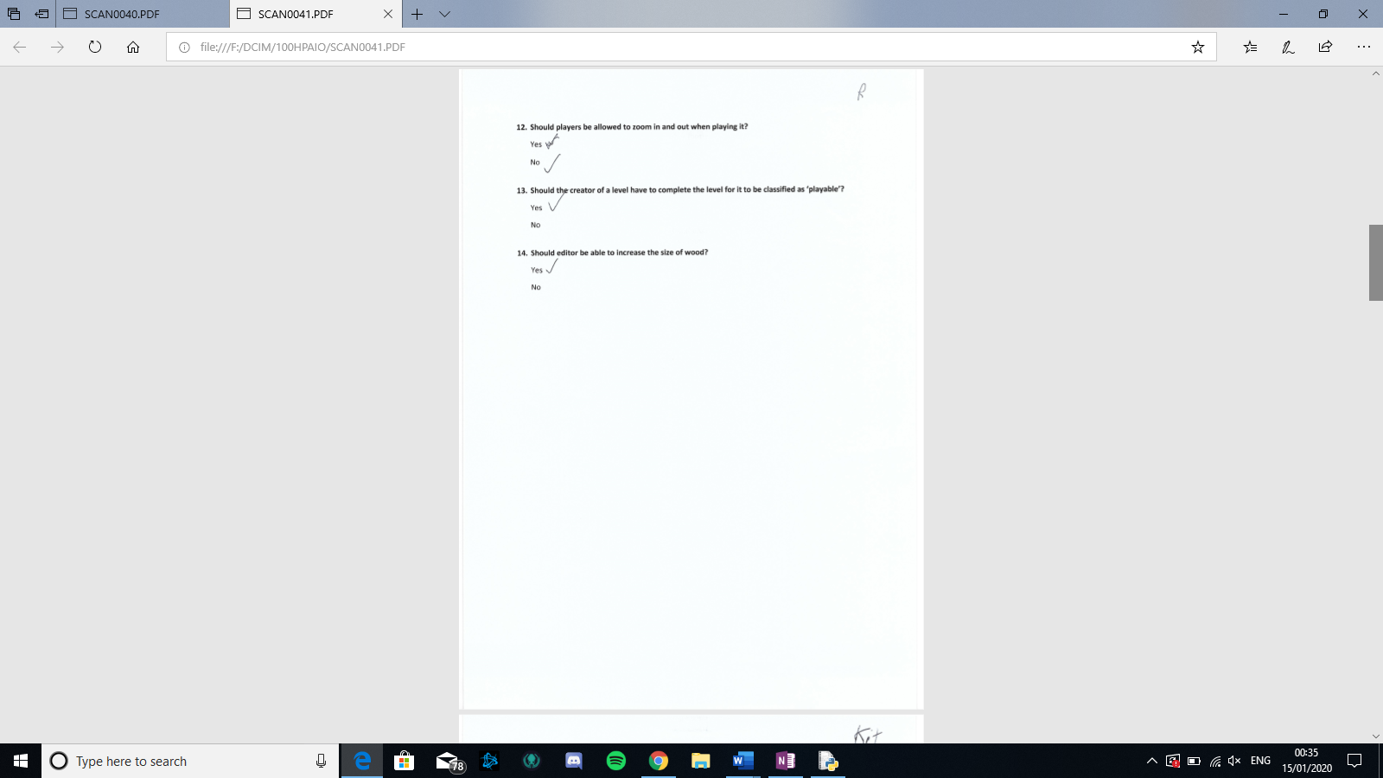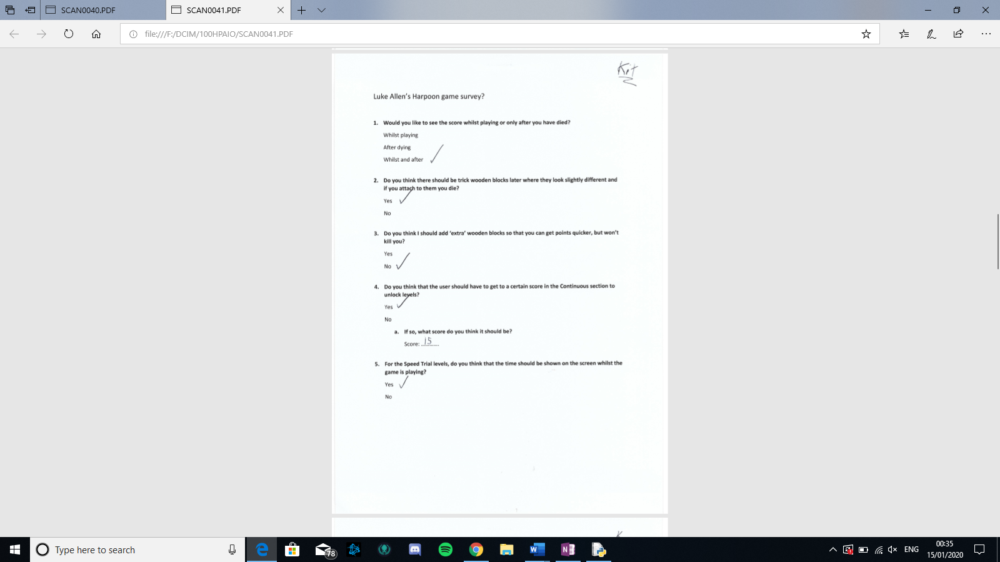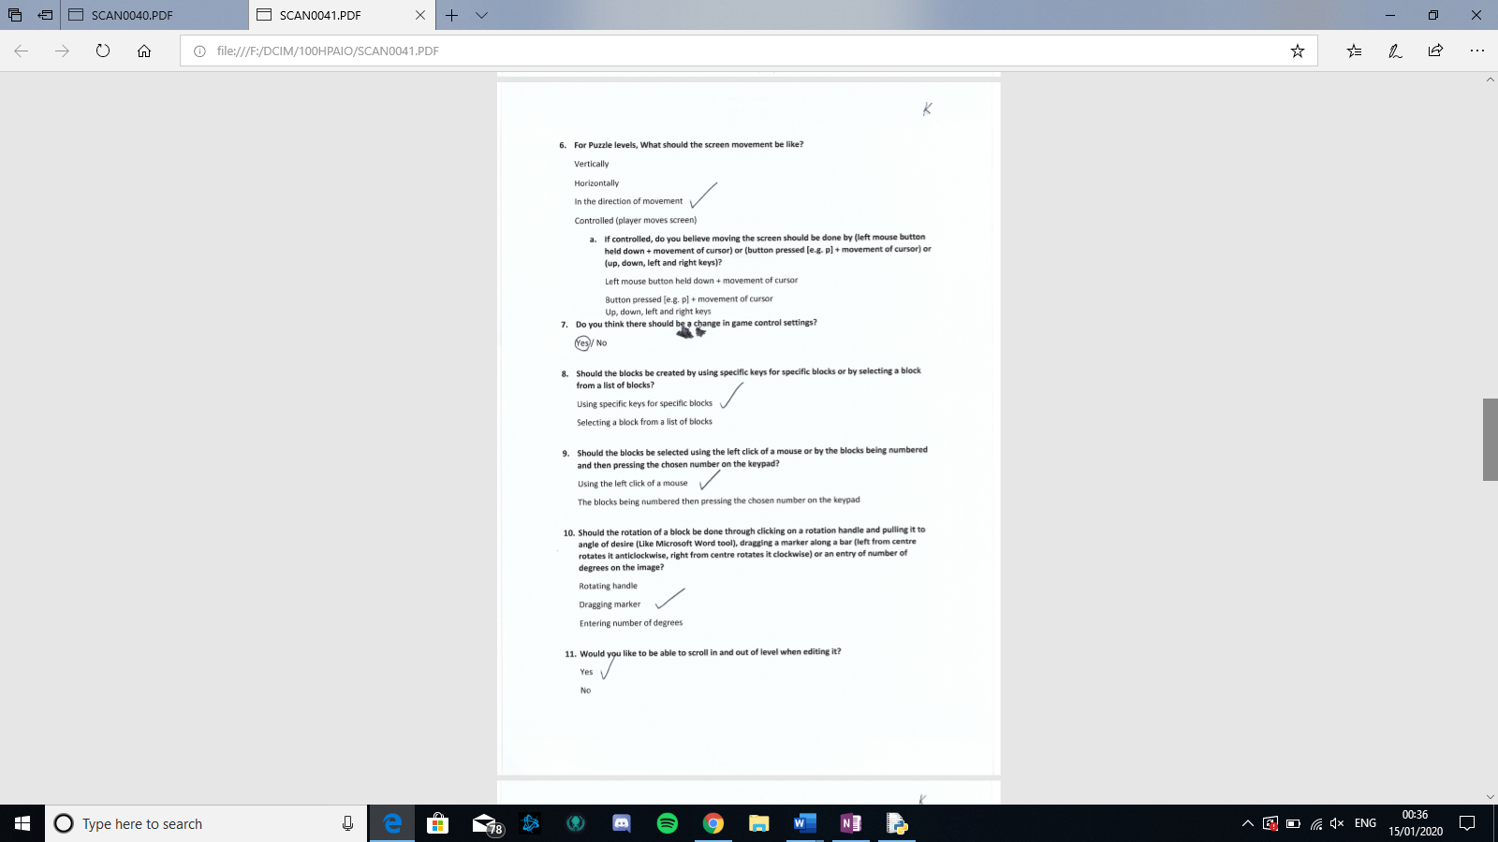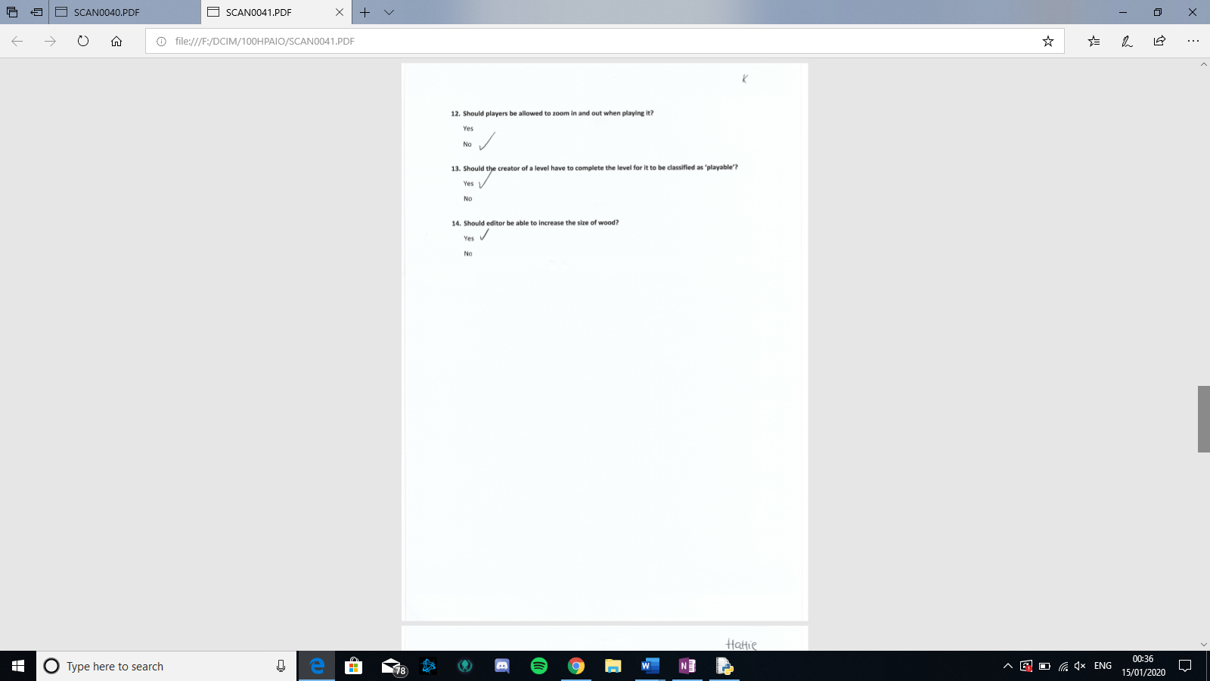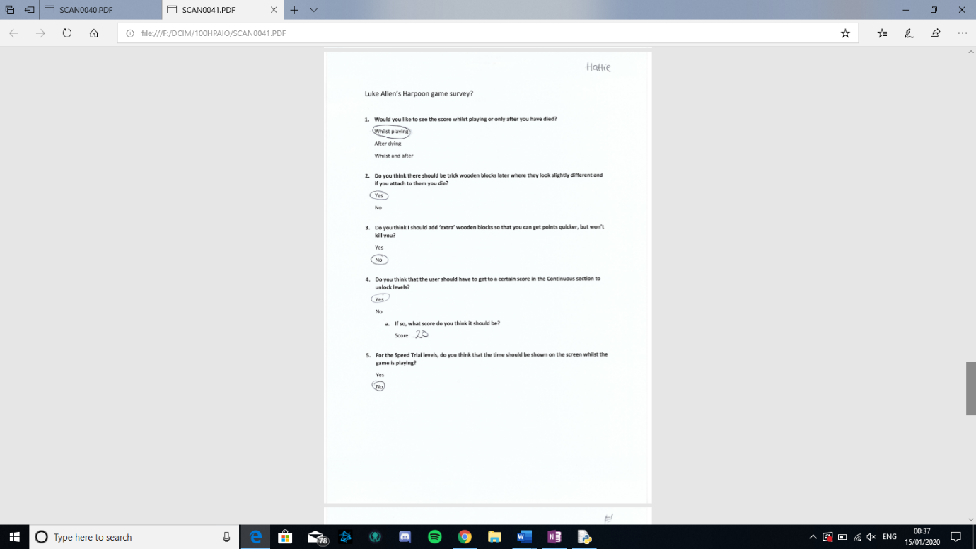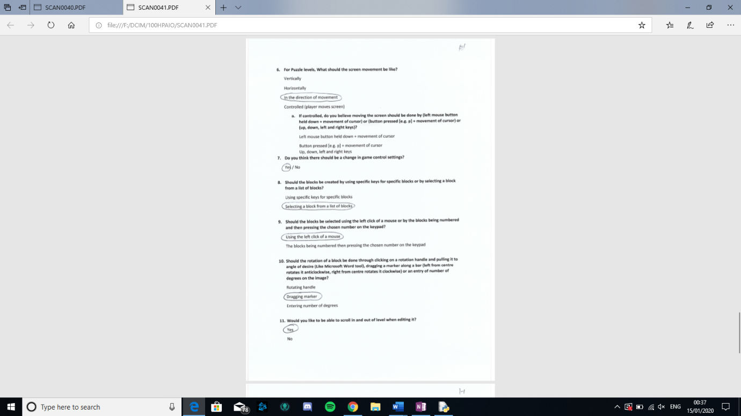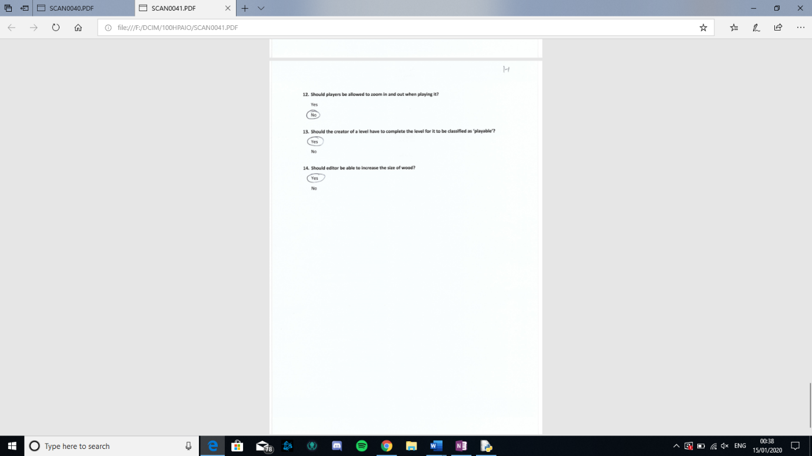

Questionnaire analysis

|  |  |  |  |  |  |
| --- | --- | --- | --- | --- | --- |
|  | Option 1 | Option 2 | Option 3 | Option 4 |  |
| Q1 | 0 | 1 | 2 |  |  |
| Q2 | 3 | 0 |  |  |  |
| Q3 | 0 | 3 |  |  |  |
| Q4 | 3 |  |  |  |  |
| Q5 |  |  |  |  |  |
| Q6 |  |  |  |  |  |
| Q7 |  |  |  |  |  |
| Q8 |  |  |  |  |  |
| Q9 |  |  |  |  |  |
| Q10 |  |  |  |  |  |
| Q11 |  |  |  |  |  |
| Q12 |  |  |  |  |  |
| Q13 |  |  |  |  |  |
| Q14 |  |  |  |  |  |

## specifications

### Hardware

Due to this game be a rather simple game with no special needs like a specific controller, the only thing needed for this game to run smoothly is the computer must have an estimate of 2GB RAM, a dual 1.5Ghz core processor, a mouse, keyboard and a screen

### Software

Because I created this game using python and pygame, the user will have to also have, excluding the game itself, python (version 3.6.2 minimum)/a python converter and also the pygame library which is all easily free and accessible online.

## Specify the proposed solution

**Necessary**

1. Continuous – when you press space, the harpoon gun will spin
2. Continuous – when you let go of space, the harpoon gun will go in the direction that it is pointing
3. Continuous – there is a death page that shows up when you die which will contain following:

* Score
* Back button
* Play again button
* Settings button

1. Continuous – the screen will scroll down
2. Levels – the levels will be unlocked when the necessary requirements are met (the previous level is completed [within a certain amount of time])
3. Levels – there is a levels page of which the player chooses from
4. Maker – can do the following:
   * Add blocks
   * Delete blocks
   * Move blocks
   * Rotate blocks
   * Create checkpoints
   * Create finish points
5. Maker – the levels can be saved, opened and played.

**Good to have**

1. Settings – you can choose the following:
   * background image
   * KLC
   * BLC
2. Continuous – the death screen will fade the game and then have the box on top
3. General – there is a settings button at the top right corner of the screen excluding home page and when game is being played.
4. Maker – has a start page where you enter details of the level:
   * Name
   * Creator
   * Time limit
5. Boosts

**Aspirational**

1. Maker – includes aspects of gravity like:
   * Can create specific areas of gravity
   * Can control the level of gravity of gravity
   * Can adjust the strength of the gravity
2. Maker – lines can do following:
   * Lines can move back and forth in set directions
   * Lines move a specified amount
3. There are optional sound affects

## Limitations of the solution

The main limitation of my solution is that the user will have to install python, this means that more storage of the user’s computer will be taken up; this also means that due to the need of python this game will not be able to be played on another console, although most of the interviewees said that they played most on pc and laptop anyway so this should be fine.

# Design

## User interface

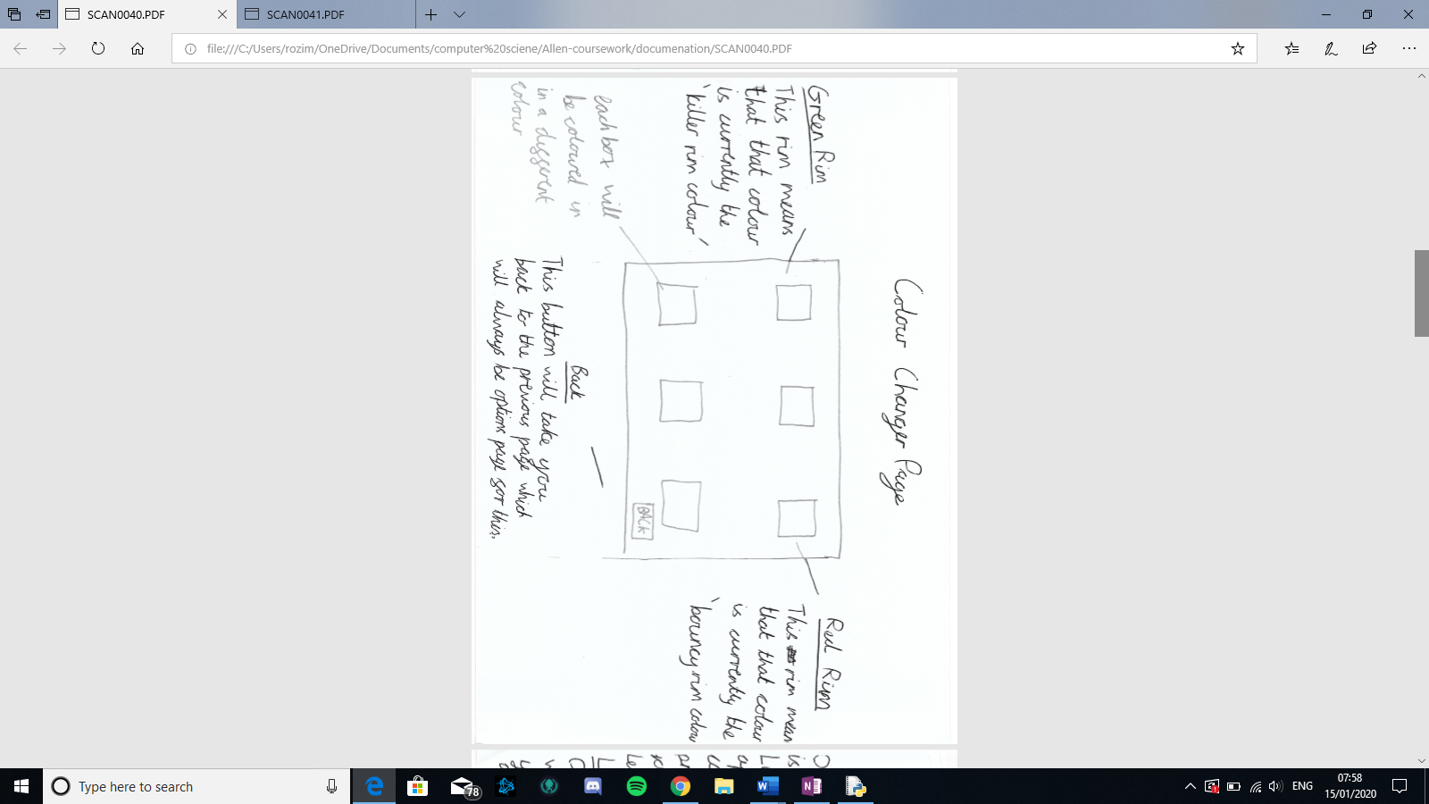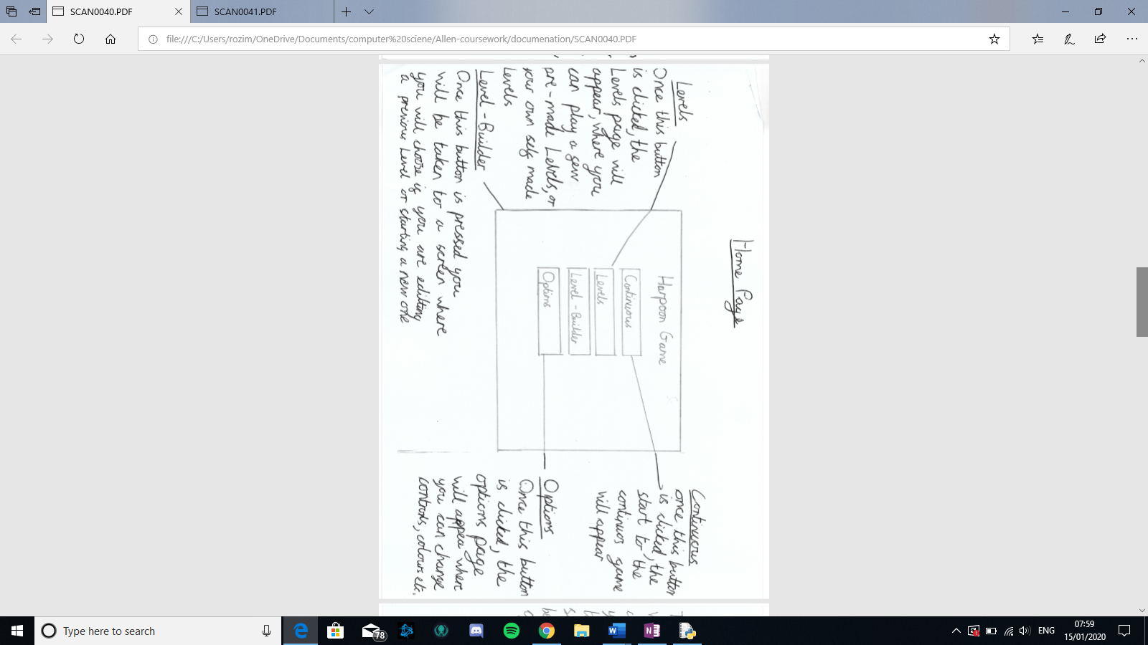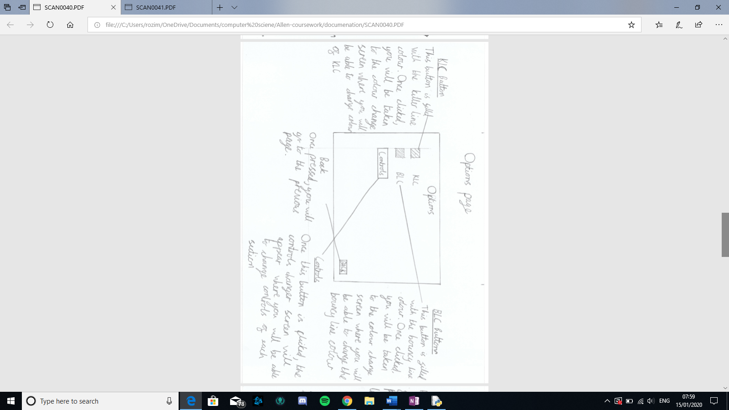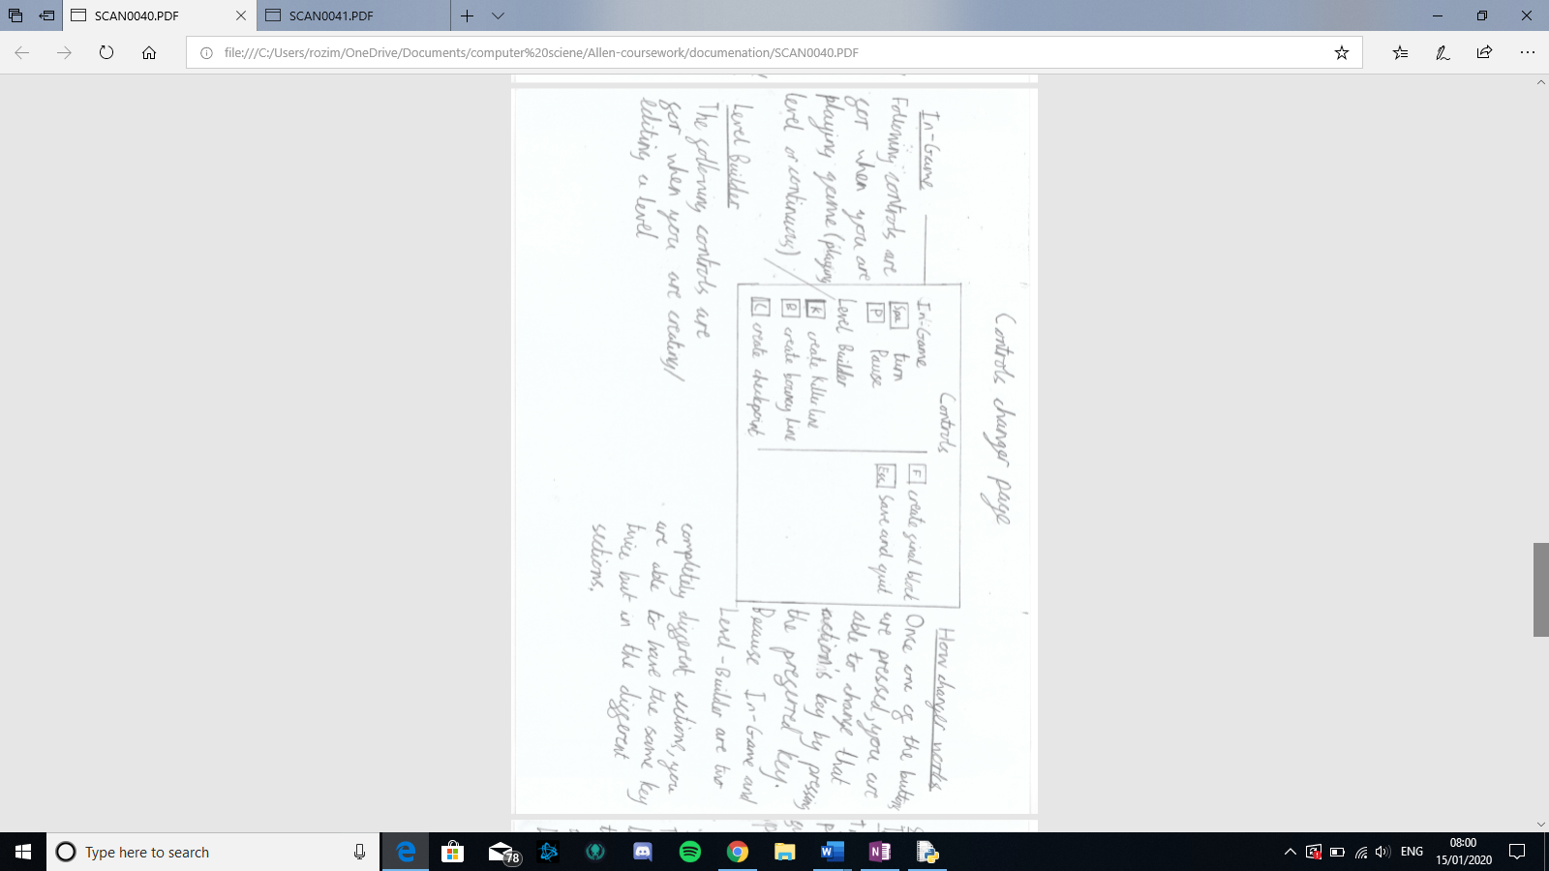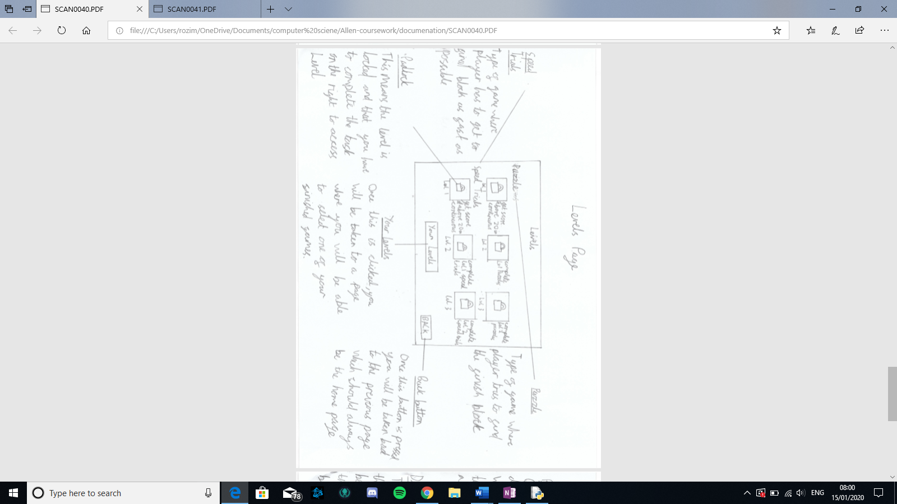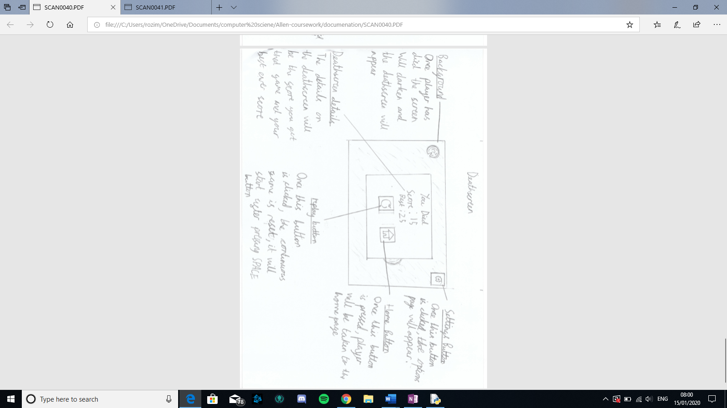

## Data structures

### Object: Sprite

What it does: This class is part of the pygame library which I will be using as a parent class so that my objects are able to cause an action when colliding with each other when in a sprite group. (I will not be writing down all the attributes and methods but only the ones which are necessary for this project.

Attributes: the attributes necessary for the methods come from the child class

Methods:

|  |  |
| --- | --- |
| Name | Explanation |
| Draw | This draws all sprites onto the screen |
| SpriteCollide | Creates a list for any sprite, that is in a group, that collides with a chosen sprite |
| GroupCollide | Creates a list for any sprites within separate groups to collide. |

### Object: Block (parent class: sprite)

What it does: This class was created as a child class of sprites which is a class from within the library pygame. The objective for the creation of this class is to be used as a parent class for Player() and create (). This means that the main use of it is to create wooden blocks/checkpoints in all 3 of the different parts of the game. These attributes are encapsulated using this class, meaning the attributes within the class are bundled together, making the program more organised.

Attributes:

|  |  |
| --- | --- |
| Name | Explanation |
| Width | This is to keep track of width of object |
| Height | This is to keep track of height of object |
| OG_image | This is needed because when turning an image in python, you have to use the original image and change that by and increasing angle otherwise it deforms the image. |
| Center | This is so that the image can be moved around its center and not in an unorderly manner. |
| Rect.x | To keep track of objects x cords/ change them |
| Rect.y | To keep track of objects y cords/ change them |
| Image_angle | So that the image can be turned properly without being deformed |
| Image | This is the image that will be printed |

Method: There are no methods to this as not all the child class’ need any of the same methods, and therefore it would make the code quicker if they had them as new methods in their separate child class’

### Object: Player (parent class: Block)

What is does: this is a child class of Block meaning that it also has all of Blocks attributes. The objective of this class was to have an encapsulation function on the player so that the player can be tracked easily on the screen due to being able to encapsulate the players position and other features.

Requirement numbers met: 1 and 2

Methods:

|  |  |
| --- | --- |
| Name | Explanation |
| Spin | This spins the player clockwise, by the “speed” |
| Move | This move player in direction that harpoon gun is pointing |

### Object: Button

What it does: This class makes Buttons of which when pressed performs a function (normally going to a different page). The main use of this class is to connect the different pages to the home page; but will also help replay a game, go to settings, see leader boards etc.

Requirement number met most of 3, most of 6 and most of 10

Attributes:

|  |  |
| --- | --- |
| Name | Explanation |
| X | This is to help with click method |
| Y | This is to help with click method |
| Width | To keep track of width for drawing object |
| Height | To keep track of height for drawing object |
| Font | Font of the word that is part of the object |
| Word | What the word is |
| Fill | What the colour of the button is |
| Outline_colour | What the colour of the rim of button is |
| Clicked | So that the program can tell when the button is clicked |
| Func | What the function of the button is |

Methods:

|  |  |
| --- | --- |
| Name | Explanation |
| Draw | This draws the button on the page when needed |
| Click | This checks if button is clicked and if so performes the function of button |

## Algorithms

### Class Block

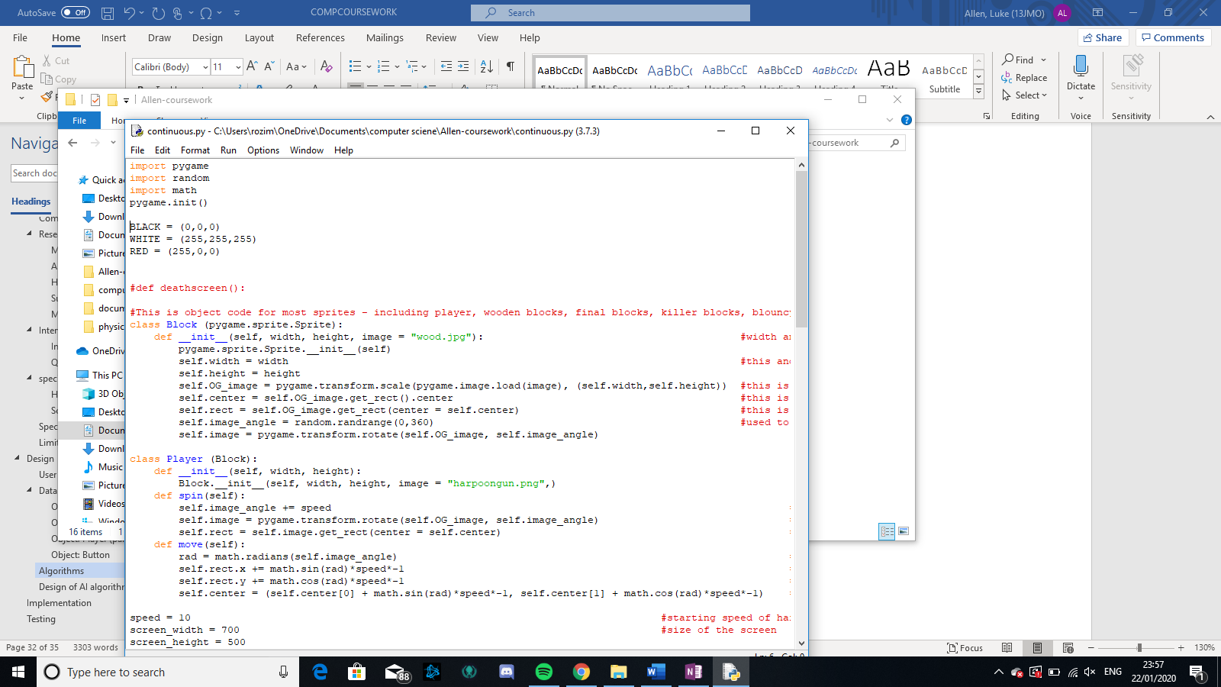

### Class Button

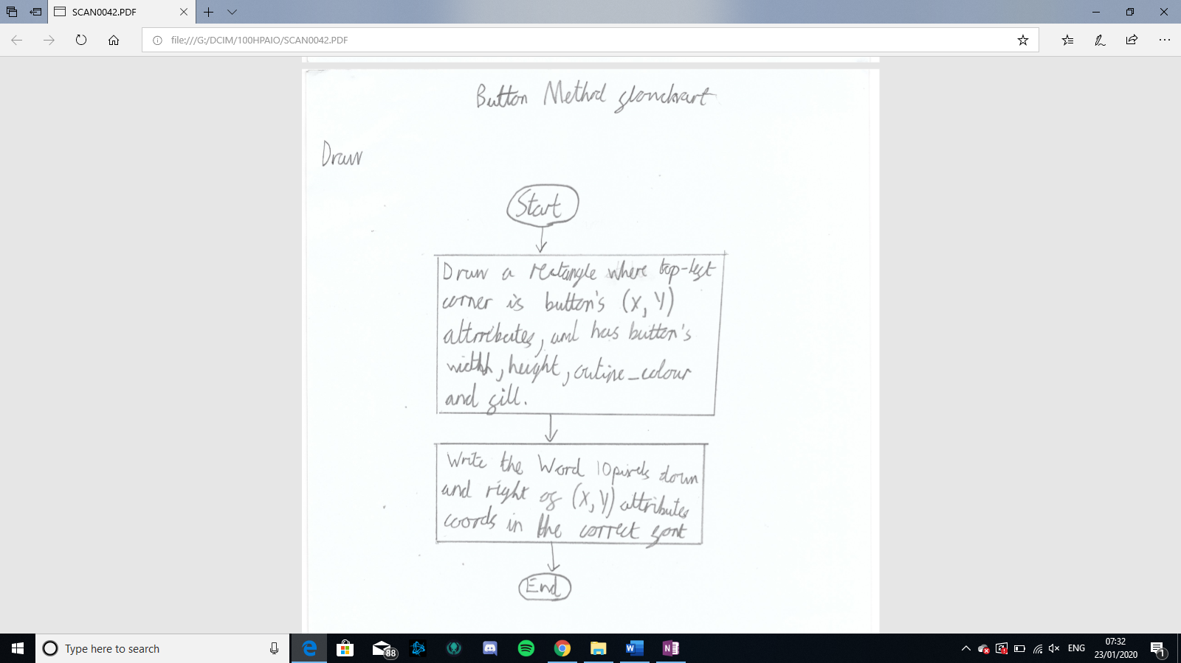

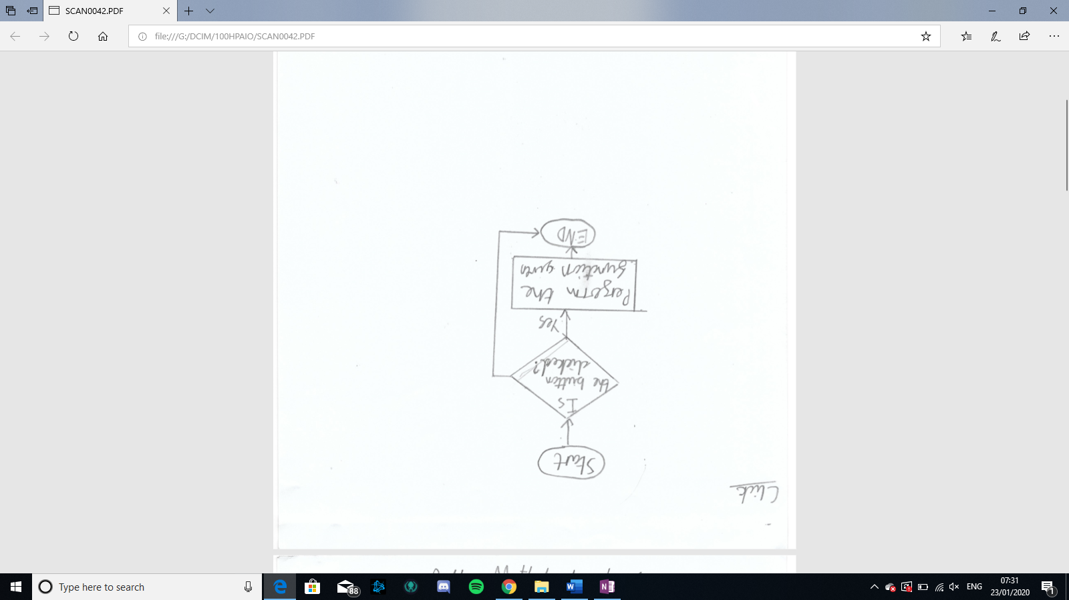

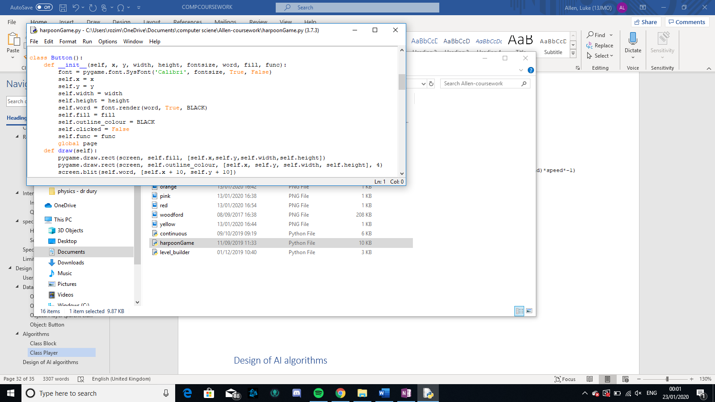

### Class Player

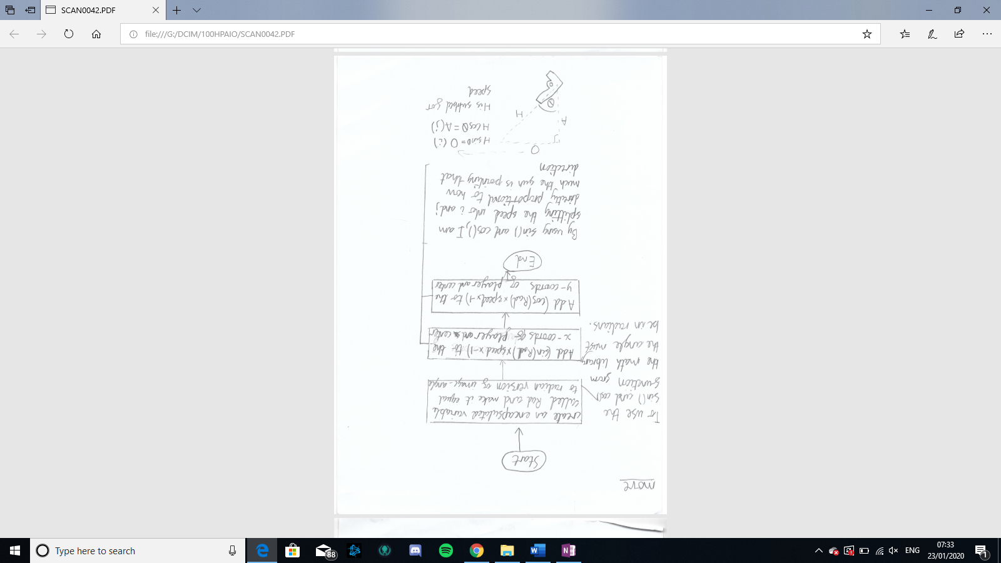

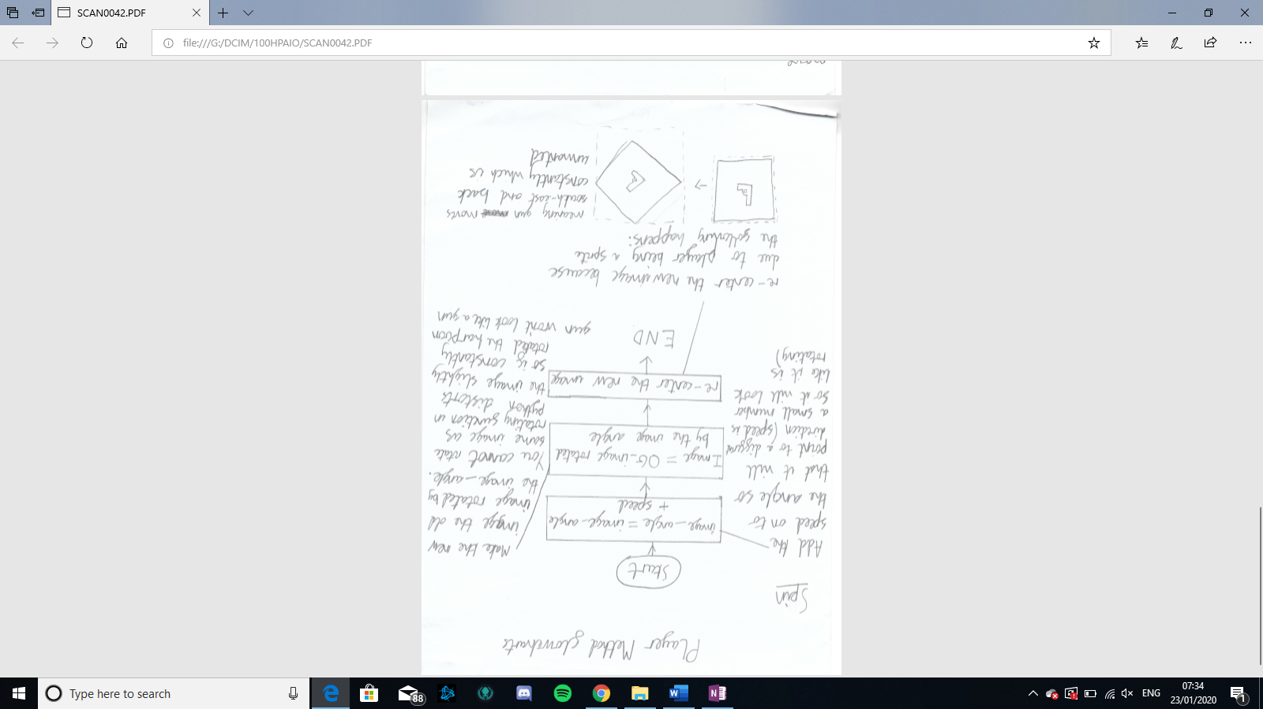

## Design of AI algorithms

# Implementation

Development model is an agile model … consisting of several iterations. Each iteration will have an implementation and then testing an devaluation which will inform the next level

Iteration 1

Game Loop

Objects on the screen

Iteration 2

Moving the objects and dealing with collisions

Iteration 3

Introduction of AI??

# Testing

|  |  |  |
| --- | --- | --- |
| **Test** | **Description** | **Exp out** |
| 1 | Screen has area 500 by 700 pixels | Screen displayed |
| 2 | When the game starts, the user will start on the home page | Home page shown |
| 3 | The home page will Say “harpoon game at top”, have a continuous, levels, level_builder and options buttons. | Home page shown |
| 4 | When the continuous button is clicked, it takes you to a page where name/nickname can be inputted | Something happens when button clicked |
| 5 | When the levels button is clicked, takes you to the levels page | Something happens when button clicked |
| 6 | When the level builder button is clicked, it will take you to the create or edit screen | Something happens when button clicked |
| 7 | When the options page is clicked, it will take you to the options page | Something happens when button clicked |
| 8 | Continuous - When typing, the letters you type appear on the screen (in the box) | Letters typed appears |
| 9 | When a typing box is selected, the outline of the box will become thicker | Outline of box becomes thick |
| 10 | Once enter is pressed, the box will disappear, and game will begin | Box disappears |
| 11 | Gun appear on screen | Gun appears |
| 12 | “press space to start” appears on screen | “press space to start” appears on screen |
| 13 | The gun is pointing at a random direction | The gun is pointing at a random direction |
| 14 | There are wooden blocks on the screen | Wooden blocks appear |
| 15 | The blocks appear in a random x coordinate on the screen | The blocks appear in a random x coordinate on the screen |
| 16 | There is a score on the top-right of the score | Word “score:” appears |
| 17 | “press space to start” disappears when space is pressed | “press space to start” disappears |
| 18 | Gun spins when space bar is pressed | Gun spins |
| 19 | Gun spins around its center | Gun spins around center |
| 20 | Gun moves when space bar release | Gun moves |
| 21 | Gun moves in direction it is pointing | Gun moves in direction it is pointing |
| 22 | All objects on the screen moves down | All objects on the screen moves down |
| 23 | If the gun hits a block, the gun replaces the gun | Gun replaces block |
| 24 | The score goes up once, every time the gun hits a wooden block | Score goes up |
| 25 | Every time the score goes up by ten, the screen changes colour | Screen colour changes |
| 26 | If the gun hits the sides, the game ends. | Continuous game end |
| 27 | When the player dies, the screen fades | Screen fades |
| 28 | After death, there is a death screen with replay, home and leader board buttons and shows your best and current score and a settings button in top right corner | Death screen appears |
| 29 | When settings buttons are clicked they will go to settings | Settings appear |
| 30 | If the replay button is pressed, continuous game restarts | Continuous game reappears |
| 31 | If the home button is pressed, the player is taken back to the home screen | Home screen appears |
| 32 | If the leader board button is pressed, a leader board of top ten will come up with the rank, name and score. There will also be a back button | Leaderboard appears |
| 33 | If a back button is pressed, then the player will be taken back to the previous page | Previous page appears |
| 34 | Levels – The levels page loads, with the 3 continuous levels and 3 speed trial levels and a button to play self-created levels | Levels page appears |
| 35 | When a level is clicked the user is taken to the level and the wooden blocks, kl blocks and blocks and final block appears | Level appears |
| 36 | the blocks appear in correct positions | Blocks appear correctly |
| 37 | The blocks do not go down | Blocks don’t move down |
| 38 | The screen always has the player at the center of the screen |  |
| 39 | There is a kl at the edge of the levels so that the player can know where the maps ends. |  |
| 40 | when the player dies on a level, the deathscreen also has another levels button. |  |
| 41 | When the self built levels button is clicked then a list of the levels |  |
| 42 | The self built list will have the levels name, creator, date modified. |  |
| 43 | When a locked level is clicked, a large lock sign will appear for a second, then go away |  |
| 44 | If someone hovers of their mouse over a lock, a message will appear saying what you have to do to play this feature. |  |
| 45 | In level builder – once button is clicked a screen with only two buttons will appear, one saying “create new” and the other saying “edit” |  |
| 46 | The edit button will not work if there are no existing levels |  |
| 47 | If the create new button is hit user will be taken to a page where they input name of level, name of creator, and difficulty out of 3 they would find it. Then there will be a be a button saying start creation |  |
| 48 | When start creation is pressed, you will be taken to a blank screen with only the options buttons and a save and quit button |  |
| 49 | On the blank screen if the kl key is pressed, a killer line will appear |  |
| 50 | If bl key is pressed, bouncy line will appear |  |
| 51 | If checkpoint key is pressed, checkpoint will appear |  |
| 52 | If final block button is pressed, final block will appear. |  |
| 53 | if a block is clicked on, it will be “selected”, a dotted line will appear around it, it will have small circle at corners and sides and there will be a drag bar at the bottom of screen |  |
| 54 | If one of the small circles are clicked and pulled, then the shape of block will change | Possible lock on level builder button |
| 55 | If the drag bar is pulled, then the object will rotate |  |
| 56 | If the main area of the object is clicked, then it will be dragged wherever the mouse goes |  |
| 57 | The outline of area can be selected and grown |  |
| 58 | If you click on a random piece of area, that will become start point |  |
| 59 |  |  |
| 60 |  |  |
| 61 |  |  |
| 62 |  |  |
| 63 |  |  |

**Necessary**

1. Continuous – when you press space, the harpoon gun will spin
2. Continuous – when you let go of space, the harpoon gun will go in the direction that it is pointing
3. Continuous – there is a death page that shows up when you die which will contain following:

* Score
* Back button
* Play again button
* Settings button

1. Continuous – the screen will scroll down
2. Levels – the levels will be unlocked when the necessary requirements are met (the previous level is completed [within a certain amount of time])
3. Levels – there is a levels page of which the player chooses from
4. Maker – can do the following:
   * Add blocks
   * Delete blocks
   * Move blocks
   * Rotate blocks
   * Create checkpoints
   * Create finish points
5. Maker – the levels can be saved, opened and played.

**Good to have**

1. Settings – you can choose the following:
   * background image
   * KLC
   * BLC
2. Continuous – the death screen will fade the game and then have the box on top
3. General – there is a settings button at the top right corner of the screen excluding home page and when game is being played.
4. Maker – has a start page where you enter details of the level:
   * Name
   * Creator
   * Time limit
5. Boosts

**Aspirational**

1. Maker – includes aspects of gravity like:
   * Can create specific areas of gravity
   * Can control the level of gravity of gravity
   * Can adjust the strength of the gravity
2. Maker – lines can do following:
   * Lines can move back and forth in set directions
   * Lines move a specified amount
3. There are optional sound affects

# Evaluation